**Reduction of Current**

**Harmonics using DSTATCOM**

Major Project Report Submitted in partial fulfilment of the

requirement for under graduate degree of

**Bachelor of Technology**

In

**Electrical and Electronics Engineering**

By

**R. Venkata Koushik**

**P. V. Rama Kashyap**

**H. Hemanth Sagar**

**K. Akhil**

Under the Guidance of

**Mr. N. Prashanth,** M. Tech

Assistant Professor



Department of Electrical and Electronics Engineering

GITAM School of Technology

GITAM (Deemed to be University), Hyderabad-502329

**DECLARATION**

We submit this major project work entitled **“Reduction of Current Harmonics using DSTATCOM”** to GITAM (Deemed to be University) UNIVERSITY, Hyderabad in partial fulfilment of the requirements for the award of the degree of “**Bachelor of Technology**” in “**Electrical and Electronics Engineering**”, Department of Electrical, Electronics and Communication Engineering. we declare out that it was carried by us under the guidance of Mr. N. Prashanth Asst. Prof, GITAM (Deemed to be University), Hyderabad, India.

The results embodied in this report have not been submitted to any other University or Institute for the award of any degree or diploma.

Place: HYDERABAD

Date:

P.V.R Kashyap

R.V Koushik

K. Akhil

H. Hemanth



GITAM (Deemed to be University),

Hyderabad-502329, Date:

**CERTIFICATE**

This is to certify that the major project Report entitled **“Reduction of Current Harmonics using DSTATCOM”** is being submitted by H. Hemanth Sagar (2210516106), K. Akhil (2210516107), P.V. Rama Kashyap (2210516109), R. Venkata Koushik (2210516111)in partial fulfillment of the requirement for the award of **Bachelor of Technology in** **Electrical and Electronics Engineering,** Department Of **Electrical**, **Electronics and communication engineering (**EECE),**and** GITAM (Deemed to be University), Hyderabad.

It is faithful record work carried out by them at the **EECE Department**, GITAM (Deemed to be University), Hyderabad Campus under my guidance and supervision.

**Mr. N. Prashanth**

**Dr. K. MANJUNATHA CHARI**

Assistant Professor

Professor and HOD

Department of EECE

Department of EECE

**ACKNOWLEDGEMENT**

Apart from my effort, the success of this project largely depends on the encouragement and guidance of many others. we take this opportunity to express my gratitude to the people who have helped me in the successful competition of this project.

We would like to thank respected **Prof. N. Siva Prasad**, Pro Vice Chancellor, GITAM, Hyderabad.

We would like to thank respected **Dr. K. Manjunatha Chari,** Head of the Department of Electrical, Electronics and Communication Engineering for giving me such a wonderful opportunity to expand my knowledge for my own branch and giving me guidelines to present a project report. It helped me a lot to realize of what I study for.

We would like to thank to respected faculties **Mr. Prashanth** who helped me to make this project a successful accomplishment.

We would like to thank my friends who helped me to make my work more organized and well-stacked till the end.

**ABSTARCT**

Power quality problem is one of the major issues faced by the power companies, both at utility level and the distribution level. It basically causes problems such as voltage sag, voltage swell, induction of higher order harmonics, etc.

Modern day electrical and electronic load used at homes, industries and for electric traction are non-linear in nature and thought to culprit for these problems.

So, in this project we implement and simulate Simulink model to mitigate some of the power quality problems using DSTATCOM.

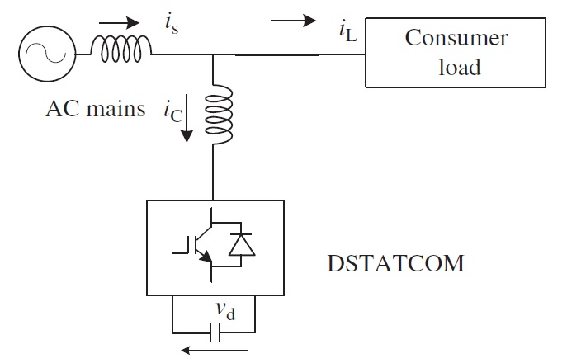

**Contents**

Figures 7

1 Introduction 9

2 Literature Review 10

3 Methodology 11

3.1 DSTATCOM 11

3.1.1 Classification of DSTATCOMs: 11

3.1.2 Converter Based Classification: 12

3.1.3 Topology Based Classification: 12

3.1.5 THREE PHASE FOUR WIRE SYSTEM 13

3.1.5 PRINCIPLE OF OPERATION OF DSTATCOM 13

3.1.6 CONTROL OF DSTATCOM: 14

3.2 Instantaneous reactive power theory (IRPT) Algorithm: 16

3.3 Design of DSTATCOM 18

3.3.1 Determining DC bus Voltage 18

3.3.2 Selecting DC Bus Capacitor 18

3.3.3 Selecting Coupling Inductor 18

3.4 Hysteresis Current Controller 19

4 Simulation and Results 20

4.1 Simulation Parameters 20

4.2 Blocks Used 20

4.2.1 Three-Phase Programmable Voltage Source 20

4.2.3 Three-Phase V-I measurement 20

4.2.3 Series RLC Branch 21

4.2.4 Three-Phase Series RLC Branch 21

4.2.5 Voltage Measurement 21

4.2.6 Current Measurement 21

4.2.7 Scope 22

4.2.6 Series RLC Load 22

4.2.7 Universal Bridge 22

4.2.8 Subsystem 23

4.2.9 Clarke Transform 23

4.2.10 Inverse Clarke Transform 23

4.2.11 Fcn 23

4.2.12 Hysteresis Current Controller 23

4.2.13 powergui 24

4.2.14 Mux 24

4.2.14 Demux 24

4.3 Simulink Model and Observations 25

4.3.1 Case 1 25

4.3.2 Case 2 31

4.4 Result 37

5 References 38

6 Conclusion 39

# Figures

Figure 1 A VSC based DSTATCOM 12

Figure 2 Topology classification of three-phase three-wire DSTATCOMs 13

Figure 3 A three-leg VSC and split capacitor based three phase four wire DSTATCOM connected to a three phase four wire system. 14

Figure 4 Topology classification of three-phase four-wire DSTATCOM 15

Figure 5 IRPT-based control algorithm of DSTATCOM 17

Figure 6 Schematic Representation of Hysteresis Current Controller 19

Figure 7 Three-Phase Programmable Voltage Source 20

Figure 8 Three-Phase V-I measurement 20

Figure 9 Series RLC Branch 21

Figure 10 Three-Phase Series RLC Branch 21

Figure 11 Voltage Measurement 21

Figure 12 Current Measurement 21

Figure 13 Scope 22

Figure 14 Series RLC Load 22

Figure 15 Universal Bridge 22

Figure 16 Subsystem 23

Figure 17 Clarke Transform 23

Figure 18 Inverse Clarke Transform 23

Figure 19 Fcn 23

Figure 20 Hysteresis Current Controller 24

Figure 21 powergui 24

Figure 22 Mux 24

Figure 23 Demux 24

Figure 24 Simulation Diagram with DSTATCOM connected for Case 1 26

Figure 25 DSTATCOM Model 27

Figure 26 Waveforms of Source and Load Currents in Case 1 when DSTATCOM is not connected 28

Figure 27 Waveforms of Source and Load Currents in Case 1 when DSTATCOM is connected 28

Figure 28 Screenshot of FFT Analysis of Case 1 when DSTATCOM is not connected 29

Figure 29 Screenshot of FFT Analysis of Case 1 when DSTATCOM is connected 29

Figure 30 Load Voltages for Case 1 when DSTATCOM is not Connected 30

Figure 31 Load Voltages for Case 1 when DSTATCOM is connected 30

Figure 32 DSTATCOM Currents 30

Figure 33 Model for Case 2 32

Figure 34 FFT Analysis when Inductive load is switched ON when DSTATCOM is disconnected 33

Figure 35 Analysis when Inductive load is switched ON when DSTATCOM is connected 33

Figure 36 Analysis when Capacitive load is switched ON when DSTATCOM is disconnected 34

Figure 37 Analysis when Capacitive load is switched ON when DSTATCOM is connected 34

Figure 38 Source, Load and DSTATCOM currents 35

Figure 39 Active and reactive powers at Source, Load and DSTATCOM. Here Blue represents active and orange represents reactive power respectively. 35

Figure 40 FFT Analysis of source voltage for case 1 with DSTATCOM connected 36

Figure 41 FFT Analysis of source voltage for case 2 with DSTATCOM connected 36

# 1 **Introduction**

A DSTATCOM is basically a STATCOM implemented at the distribution level of power system. It’s one of the mature technologies in all mitigating power quality problems.

When compared with classical power quality improvement techniques - Static VAR compensators, DSTATCOM can mitigate all current related power quality problems.

Moreover, with the development of new control algorithms, latest power electronic devices and measurement instruments it able to mitigate power quality problems more effectively at distribution side.

Traditionally, DSTATCOM was implemented using Bipolar Junction Transistor (BJT) but with the development of Insulated Gate Bipolar Transistor (IGBT), it is preferred and is considered as the ideal power electronic device to construct DSTATCOM.

In this project we implement and observe the output of a Simulink model of DSTATCOM to compensate current related harmonics.

# 2 Literature Review

Modern day electrical and electronic loads such as static power convertors and arc furnaces are non-linear in nature. They introduce power quality problems such as harmonic contamination, increased harmonic demand, voltage fluctuations, etc.

The current harmonics so produced can cause high losses in electrical equipment’s, heating of rotatory machines and can interfere with the communication lines, if they are nearby [2].

Traditionally, passive LC filters were used to overcome the problem, but they posed problems such as

1. Effect of impedance on filtering characteristics.
2. Chances of getting overloaded when harmonics increase.
3. Chances of harmonics getting amplified

In an order to overcome these problems Active power compensator such as DSTATCOM is proposed [3]. These Active power compensators are quite reliable and cost effective [1].

For controlling DSTATCOM many Time and Frequency based algorithms like PI control algorithm, SRF control algorithm, Kalamn filter based algorithm, Wavelet transform based algorithm, etc. have been proposed [4].

In this project we implement Instantaneous Reactive Power Theory based algorithm proposed by Akagi [5] to control the DSTATCOM to mitigate current harmonics.

# 3 Methodology

This section includes information about the major components used in this project.

## 3.1 DSTATCOM

The custom power devices namely, DSTATCOMs (distribution static compensators), are used to mitigate some of the problems depending upon the requirements. DSTATCOMs are extensively used for mitigating the current-based power quality problems. There are a number of current-based power quality problems such as poor power factor, or poor voltage regulation, unbalanced currents, and increased neutral current. Therefore, depending upon the problems, the configuration of the DSTATCOM is selected. The DSTATCOM technology used for providing reactive power compensation, load balancing, and or neutral current and harmonic current compensation (if required) in AC distribution networks. We use solid-state devices. These compensating devices are also used to regulate the terminal voltage, suppress voltage flicker, and improve voltage balance in three-phase systems. These objectives are achieved either individually or in combination depending upon the requirements and the control strategy and configuration that need to be selected appropriately.

DSTATCOMs are basically categorized into three types, namely, single-phase two-wire, three-phase three-wire, and three-phase four-wire configurations, to meet the requirements of three types of consumer loads on supply systems.

Single-phase loads such as domestic lights and ovens, TVs, computer power supplies, air conditioners, laser printers, and Xerox machines cause power quality problems.

Single-phase two-wire DSTATCOMs have been investigated in varying configurations and control strategies to meet the needs of single-phase systems. Both current source converters (CSCs) with inductive energy storage and voltage source converters (VSCs) with capacitive energy storage are used to develop single phase DSTATCOMs.

### 3.1.1 Classification of DSTATCOMs:

Classification based on:

1. Type of converter used
2. Topology
3. The number of phases.

### 3.1.2 Converter Based Classification:

Two types of converters are used to develop DSTATCOM. One is csc bridge and the other is voltage source converter (VSC) based. Csc based DSTATCOM are considered sufficiently reliable, but have high losses and require high values of parallel AC power capacitors. VSC based DSTATCOM has a self-started supporting DC voltage with large DC capacitors. It is more widely used because it is light, cheap and expandable with lower performance of switching frequencies.

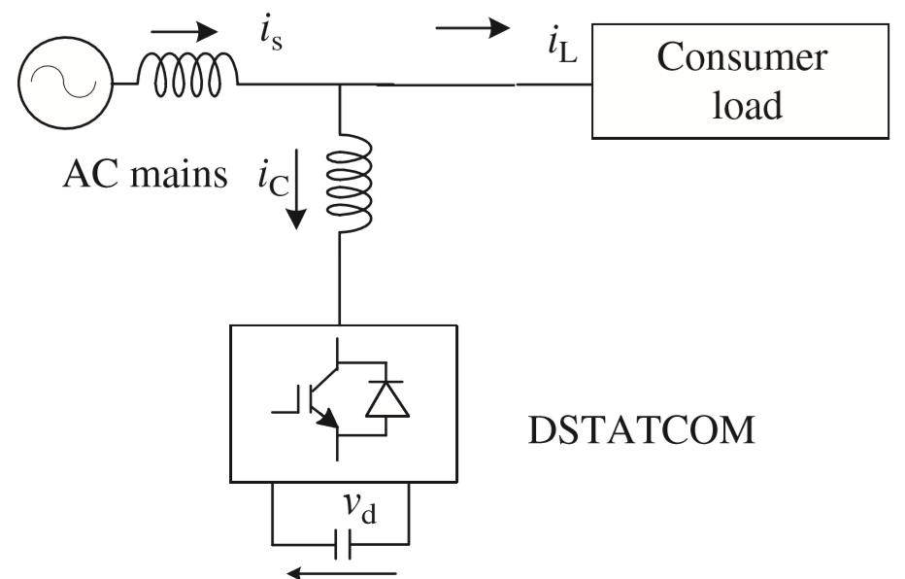

Figure 1 A VSC based DSTATCOM

### 3.1.3 Topology Based Classification:

DSTATCOMS are also classified based on topology. VSC without transformer, VSC with non-isolated transformers, VSC with isolated transformers.

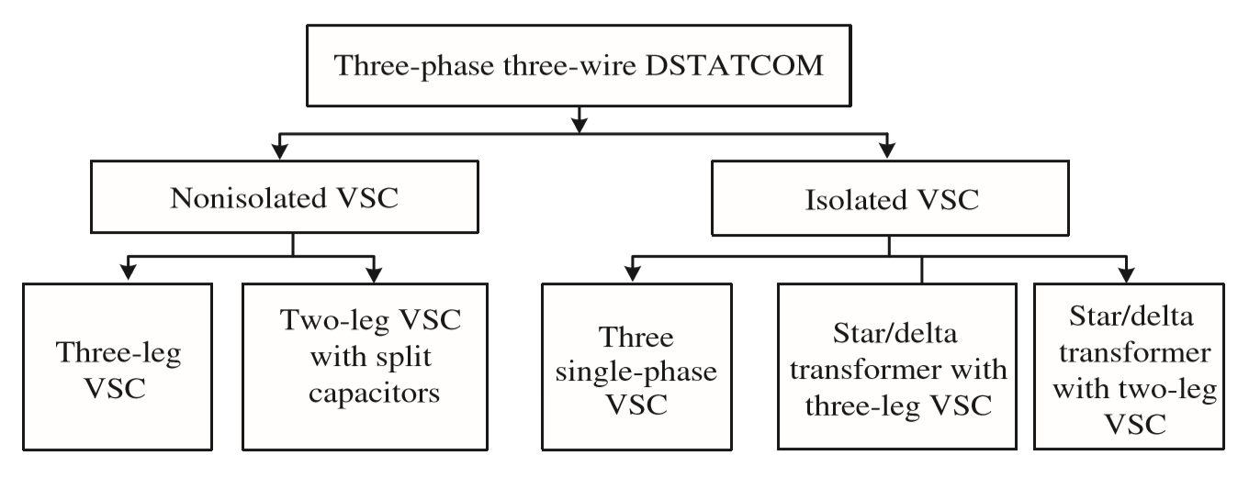

Figure 2 Topology classification of three-phase three-wire DSTATCOMs

Depending upon phases these are further classified into

1. single-phase two wire
2. Three-phase three-wire
3. Three-phase four-wire systems.

### 3.1.5 THREE PHASE FOUR WIRE SYSTEM

In a three-phase four-wire distribution system, there are three-phase loads and single-phase loads depending upon the consumers’ demands. This results in severe burden of unbalanced currents along with the neutral current on the distribution feeder. To prevent the unbalanced currents from being drawn from the distribution bus, a shunt compensator, also called DSTATCOM, can be used. It ensures that the currents drawn from the distribution are balanced and sinusoidal and, moreover, the neutral current is compensated.

### 3.1.5 PRINCIPLE OF OPERATION OF DSTATCOM

DSTATCOM is used to mitigate the power quality problems majorly current based power quality problems. It mitigates most of the power quality problems such as reactive power, harmonics, and fluctuations.

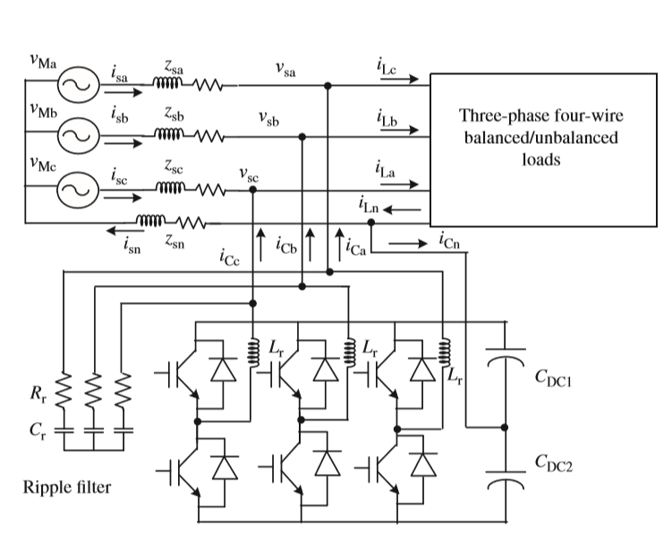

Figure 3 A three-leg VSC and split capacitor based three phase four wire DSTATCOM connected to a three phase four wire system.

DSTATCOM has a VSC connected to a DC bus and its AC sides are connected in shunt across the load. The VSC uses PWM control therefore it requires small ripple filters to mitigate switching ripples. It requires hall effect voltage and current sensors for feedback signals. The VSC is normally controlled in PWM current control mode. A control algorithm is required for the solid-state devices in order to provide gating signals. DSTATCOM also needs DC bus capacitors, small passive filters, isolation transformers.

In the project a three-phase split capacitor VSC is used.

### 3.1.6 CONTROL OF DSTATCOM:

The main objective of a control algorithm of DSTATCOMs is to estimate the reference currents using feedback signals. These reference currents along with corresponding sensed currents are used in PWM current controllers to derive PWM gating signals for switching devices (IGBTs) of the VSC used as a DSTATCOM. Reference currents for the control of DSTATCOMs have to be derived accordingly and these signals may be estimated using a number of control algorithms. There are many control algorithms for the control of DSTATCOMs, which are classified as time-domain and frequency-domain control algorithms. There is more than a dozen of time-domain control algorithms that are used for

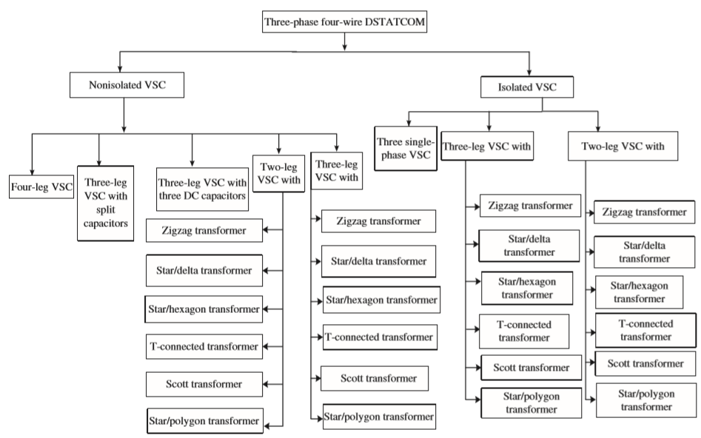

Figure 4 Topology classification of three-phase four-wire DSTATCOM

the control of DSTATCOMs. A few of these control algorithms are as follows:

* Unit template technique or PI controller-based theory
* Power balance theory (BPT)
* I cos φ control algorithm
* Current synchronous detection (CSD) method
* Instantaneous reactive power theory (IRPT), also known as PQ theory or α–β theory
* Synchronous reference frame (SRF) theory, also known as d–q theory
* Instantaneous symmetrical component theory (ISCT)
* Singe-phase PQ theory
* Singe-phase DQ theory
* Neural network theory (Widrow’s LMS-based Adaline algorithm)
* Enhanced phase locked loop (EPLL)-based control algorithm

These control algorithms are time-domain control algorithms. Most of them have been used for the control of DSTATCOMs and other compensating devices.

Similarly, there are around the same number of frequency-domain control algorithms. Some of them are as follows:

* + Fourier series theory
  + Discrete Fourier transform theory
  + Fast Fourier transform theory
  + Recursive discrete Fourier transform theory
  + Kalman filter-based control algorithm
  + Wavelet transformation theory Stockwell transformation (S-transform) theory.
  + Empirical decomposition (EMD) transformation theory

These control algorithms are frequency-domain. Most of them are used for power quality monitoring for a number of purposes in the power analyzers, PQ instruments, and so on. Some of these algorithms have been used for the control of DSTATCOMs. However, these algorithms are sluggish and slow, requiring heavy computation burden; therefore, these control methods are not too much preferred for real-time control of DSTATCOMs compared with time-domain control algorithms.

All these control algorithms may be used for the control of DSTATCOMs. one of the above-mentioned algorithms that is time based Instantaneous reactive power theory (IRPT), also known as PQ theory or α–β theory has been used in our project.

## 3.2 Instantaneous reactive power theory (IRPT) Algorithm:

The IRPT-based control algorithm of DSTATCOMs has three-phase load currents and PCC voltages are sensed and used to calculate the instantaneous active and reactive powers. Three phase PCC voltages are sensed and processed through BPFs before their transformation to eliminate their ripple contents and are denoted as (esa; esb; esc). A first-order Butterworth filter is used as a BPF**.**



Figure 5 IRPT-based control algorithm of DSTATCOM

These three-phase filtered load voltages are transformed into two-phase α–β orthogonal coordinates (vα; vβ) as

$\left({eα \atop eβ}\right)$**= $\sqrt{\frac{2}{3}}$ $\left(\begin{matrix}1 & -1/2 & -1/2 \\ 0 & \sqrt{3}/2 & -\sqrt{3}/2\end{matrix}\right)$ $\left({esa \atop \begin{aligned}esb \\ esc\end{aligned}}\right)$**

Similarly, three-phase load currents (iLa; iLb; iLc) are transformed into two-phase α–β orthogonal coordinates (iLα, iLβ) as

$\left({iLα \atop iLβ}\right)$**= $\sqrt{\frac{2}{3}}$ $\left(\begin{matrix}1 & -1/2 & -1/2 \\ 0 & \sqrt{3}/2 & -\sqrt{3}/2\end{matrix}\right)$ $\left({iLa \atop \begin{aligned}iLb \\ iLc\end{aligned}}\right)$**

From these two sets of expressions, the instantaneous active power pL and the instantaneous reactive power qL flowing into the load side are computed as

$\left({pL \atop qL}\right)$**= $\left(\begin{aligned}eα eβ \\ eβ eα \end{aligned}\right)$ $\left({iLα \atop iLβ}\right)$**

Let pL and pl barare the DC component and the AC component of pL, respectively, and qL and ~ qL are the DC component and the AC component of qL, respectively, Therefore, these may expressed as

**PL=L+L,**

**qL= L + L**

In these expressions, the fundamental load power is transformed to DC components pL and qL, and the distortion or negative sequence is transformed to AC components ~ pL and ~ qL. The DC components of active and reactive powers are extracted by using two LPFs. The reference three-phase supply currents i*sa; i* sb; andi* sc are estimated as

$$\left(\begin{matrix}i^{*}sa \\ i^{*}sb \\ i^{*}sc\end{matrix}\right)= \sqrt{2/3}\left(\begin{matrix}1 & 0 \\ -1/2 & \sqrt{3}/2 \\ -1/2 & -\sqrt{3}/2\end{matrix}\right){\left(\begin{matrix}eα & eβ \\ -eβ & eα \end{matrix}\right)}^{-1}\left(\begin{matrix}p^{*} \\ q^{*}\end{matrix}\right)$$

This IRPT-based control algorithm may easily be modified for the control on supply currents for indirect current control. In this case, for power factor correction mode of operation of the DSTATCOM and after the transformation from the α–β frame to the abc frame, three-phase transformed currents are reference supply currents and these must be compared with sensed supply.

## 3.3 Design of DSTATCOM

The split capacitor 3 phase DSTATCOM is designed as follows:

### 3.3.1 Determining DC bus Voltage

DC bus voltage depends on the instantaneous energy available to the DSTATCOM. It is determined as follows:

$$V_{DC}=2\sqrt{2}V_{LL}/\sqrt{3}m$$

Where m is modulation index which is usually set to 1. VLL is line voltage at PCC.

### 3.3.2 Selecting DC Bus Capacitor

DC bus capacitor is a component where the VDC, is stored. Its value is determined as follows:

$$C_{DC}= I_{0}/(2ωv_{DC,pp})$$

Where $v_{DC,pp}$ is ripple capacitor voltage and $I_{0}$ is Capacitor current

### 3.3.3 Selecting Coupling Inductor

This Coupling Inductor is used to reduce the Ripple in the DSTATCOM generated currents.

$$L_{r} = \sqrt{3}mV_{DC}/12af_{s}I_{cr,pp}$$

Where $f_{s}$ is pulse frequency and $I_{cr,pp}$ is ripple frequency.

## 3.4 Hysteresis Current Controller

Hysteresis Current controller generates gate pulses to the 3- phase IGBT DC-AC convertor.

It works by comparing the error signal,

$i_{e}={is}^{*}-is$

With hysteresis current band (hb) which is 1% to 5% of the current level.

If (is < is* - hb) then upper switch of VSC is OFF and lower switch is ON, else it is OFF.

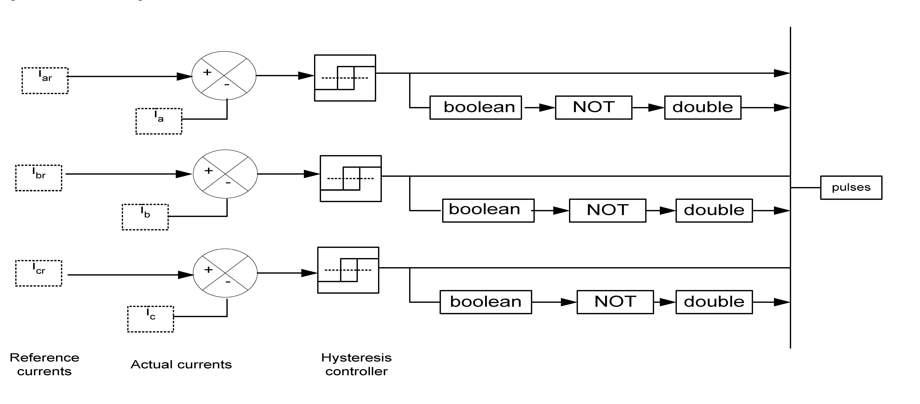

Figure 6 Schematic Representation of Hysteresis Current Controller

# 4 Simulation and Results

In this section we discuss about the simulation in Simulinkand the results obtained.

## 4.1 Simulation Parameters

Following parameters were chosen to model the DSTATCOM:

|  |  |  |
| --- | --- | --- |
| S.No | Parameter | Rating |
| 1 | Voltage Source | VL-L = 200 V, f= 50Hz |
| 2 | Line Parameters | Rline = 1Ω, Lline = 0.1mH |
| 3 | Coupling Inductor | 7mH |
| 4 | DC Storage Capacitor | 600µF |

## 4.2 Blocks Used

The following Simulink blocks were used in the modelling:

### 4.2.1 Three-Phase Programmable Voltage Source

This block is used to generate required AC voltage. This block has following parameters:

1. Voltage Amplitude
2. Phase
3. Frequency

which can be varied according to the requirement.

For Simulation purpose Phase is set to zero.

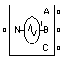

Figure 7 Three-Phase Programmable Voltage Source

### 4.2.3 Three-Phase V-I measurement

This block is used to measure Three Phase Line to Ground Voltages and Currents. This block has three input and three output ports, each for each phase line. This block can either measure voltages and currents both in SI and pu values.

For the purpose of simulation, the voltages and currents are measured in SI valued.

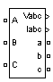

Figure 8 Three-Phase V-I measurement

### 4.2.3 Series RLC Branch

This block is used to specify Resistance and Reactance of Storage Capacitor, Load. This branch has following parameters:

1. Resistance
2. Inductance
3. Capacitance



Figure 9 Series RLC Branch

### 4.2.4 Three-Phase Series RLC Branch

This block is similar to the previous block, with a difference that it is implemented in three phases. It is used to model line parameters.

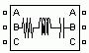

Figure 10 Three-Phase Series RLC Branch

### 4.2.5 Voltage Measurement

This block is used to measure instantaneous voltages across various loads and elements in the simulation.

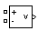

Figure 11 Voltage Measurement

### 4.2.6 Current Measurement

This Block is used to measure instantaneous current through various elements and loads in the simulation.

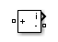

Figure 12 Current Measurement

### 4.2.7 Scope

This block plots graph taking some signal as an input.



Figure 13 Scope

### 4.2.6 Series RLC Load

This block implements linear load in terms of R, L, C. The parameters are as follows:

1. Nominal Voltage
2. Nominal Frequency
3. Active Power
4. Inductive Power
5. Capacitive Power



Figure 14 Series RLC Load

### 4.2.7 Universal Bridge

This block implements a universal three-phase power converter that consists of up to six power switches connected in a bridge configuration. The type of power switch and converter configuration are selectable from the dialog box.

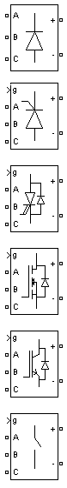

Figure 15 Universal Bridge

### 4.2.8 Subsystem

The Subsystem block consists of a subset of blocks within a block.

This Simulink model has one subsystem blocks.

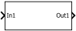

Figure 16 Subsystem

### 4.2.9 Clarke Transform

This block implements Clarke Transform to the input three-phase signal. This block outputs α, β and 0 forms of the signal.

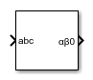

Figure 17 Clarke Transform

### 4.2.10 Inverse Clarke Transform

This block implements Inverse Clarke Transform to the input α, β and 0 forms of the signal and outputs 3 phase Signal.

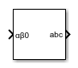

Figure 18 Inverse Clarke Transform

### 4.2.11 Fcn

The Fcn block implements specified mathematical expression to the input signal and gives it as output.

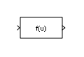

Figure 19 Fcn

### 4.2.12 Hysteresis Current Controller

This block takes in the input three-phase reference current and the three-phase load current and outputs gate pulses to the Bridge.

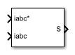

Figure 20 Hysteresis Current Controller

### 4.2.13 powergui

This is an environmental block for Simscape Electrical Specialized Power Systems models.

This block is essential to solve all power systems related models.

For the simulation purpose, this block is set to discrete mode with sample time of 5e-06 sec.



Figure 21 powergui

### 4.2.14 Mux

This block combines inputs with the same data type and complexity into a vector output. The output mux signal is flat, even if you create the mux signal from other mux signals.



Figure 22 Mux

### 4.2.14 Demux

This block performs the opposite action of Mux block.

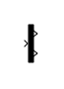

Figure 23 Demux

## 4.3 Simulink Model and Observations

### 4.3.1 Case 1

The Figure 24 shows the model of transmission line along with DSTATCOM block and load.

Fig 25 Shows the DSTATCOM.

For Case 1 following Load Parameters are considered:

|  |  |  |
| --- | --- | --- |
| S.no | Load | Parameters |
| 1 | Za | 200+j103 Ω |
| 2 | Zb | 160+j63 Ω |
| 3 | Zc | 100+j110 Ω |
| 4 | Zr | 120+j63 Ω |

Initially the simulation was carried without DSTATCOM and the observations are as follows:

1. Both source and load current were both non sinusoidal in nature.
2. By doing FFT Analysis on the Source Current (Is(abc)) it was found out that the, THD of source current was 23.69%.
3. Load voltages were pure sinusoidal in nature without any flicker.

The waveforms of source and load current for case 1 without DSTATCOM is shown in Figure 26, the FFT analysis screenshot is shown Figure 28 and the load voltage waveform is shown in Figure 30.

When simulation was carried out with DSTATCOM connected following were observed:

1. Load currents were same non sinusoidal as in the study done without DSTATCOM whereas, Source Currents appear to be somewhat sinusoidal with some flicker.
2. By doing FFT Analysis on Source Currents (Is(abc)) it was found that the, THD got reduced to 4.64% as compared to the results obtained prior to connection of DSTATCOM.
3. There was a slight flicker observed in Load voltages when DSTATCOM is connected.

The waveforms of source and load current for case 1 without DSTATCOM is shown in Figure 27, the FFT analysis screenshot is shown Figure 29 and the load voltage waveform is shown in Figure 31.

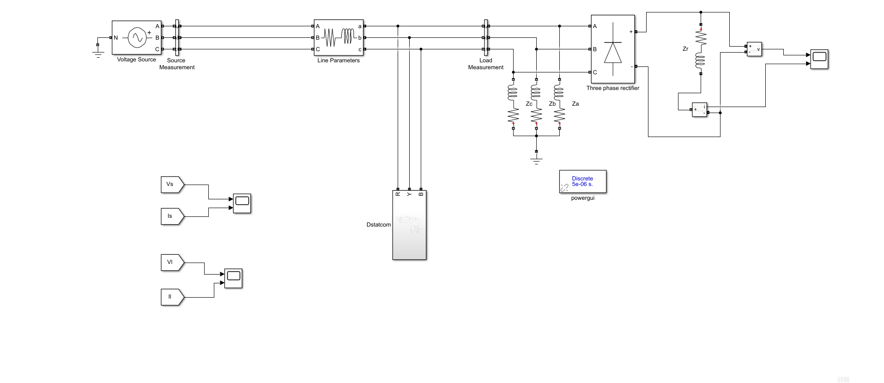

Figure 24 Simulation Diagram with DSTATCOM connected for Case 1

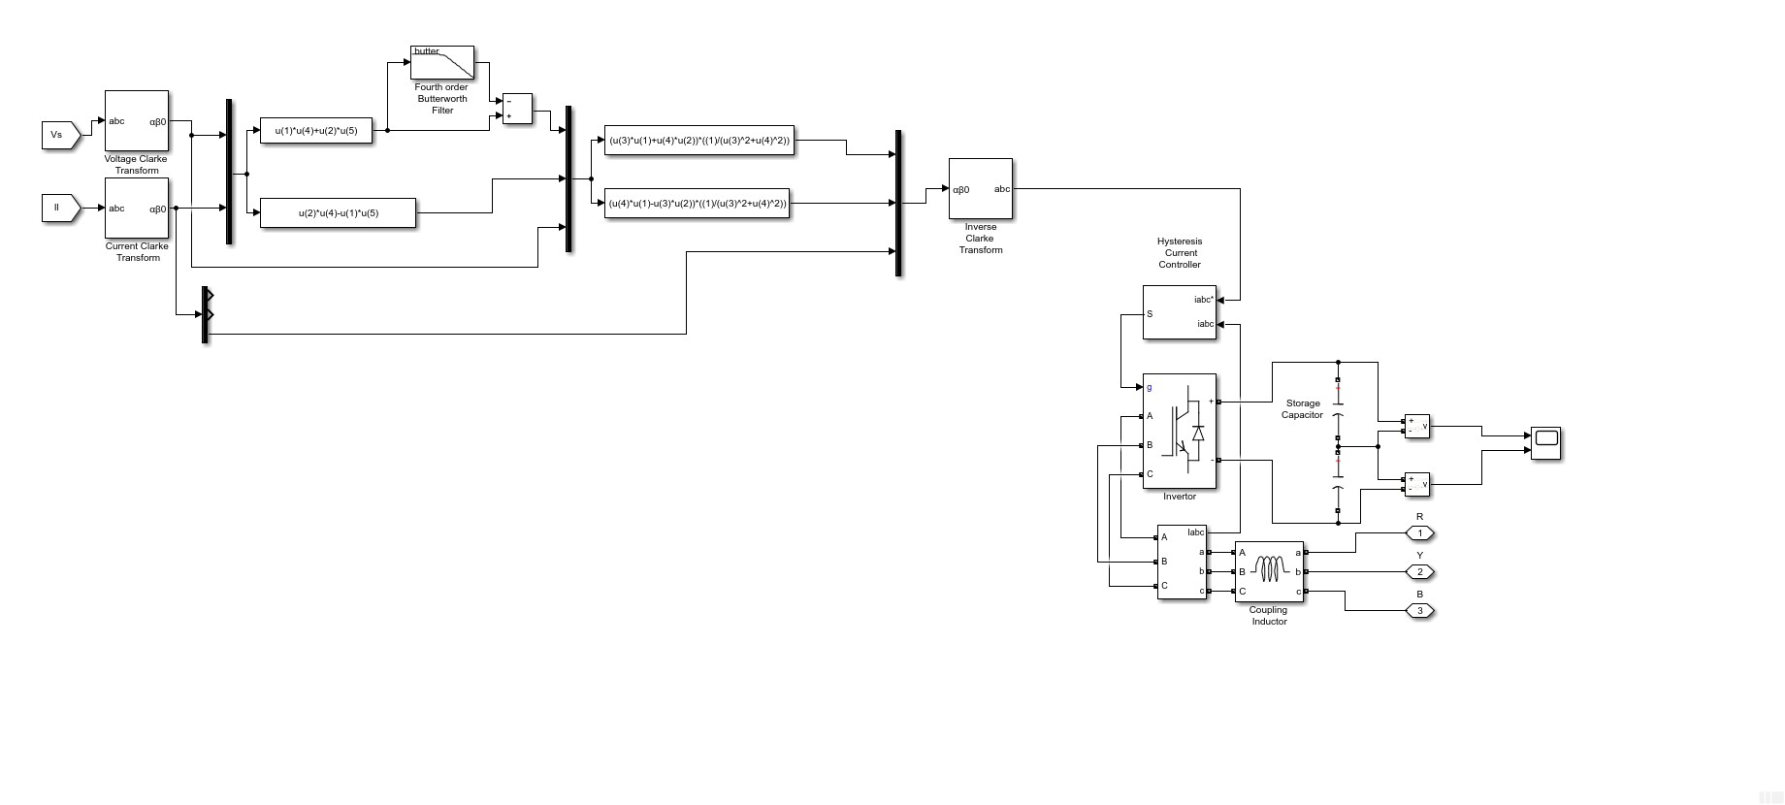

Figure 25 DSTATCOM Model

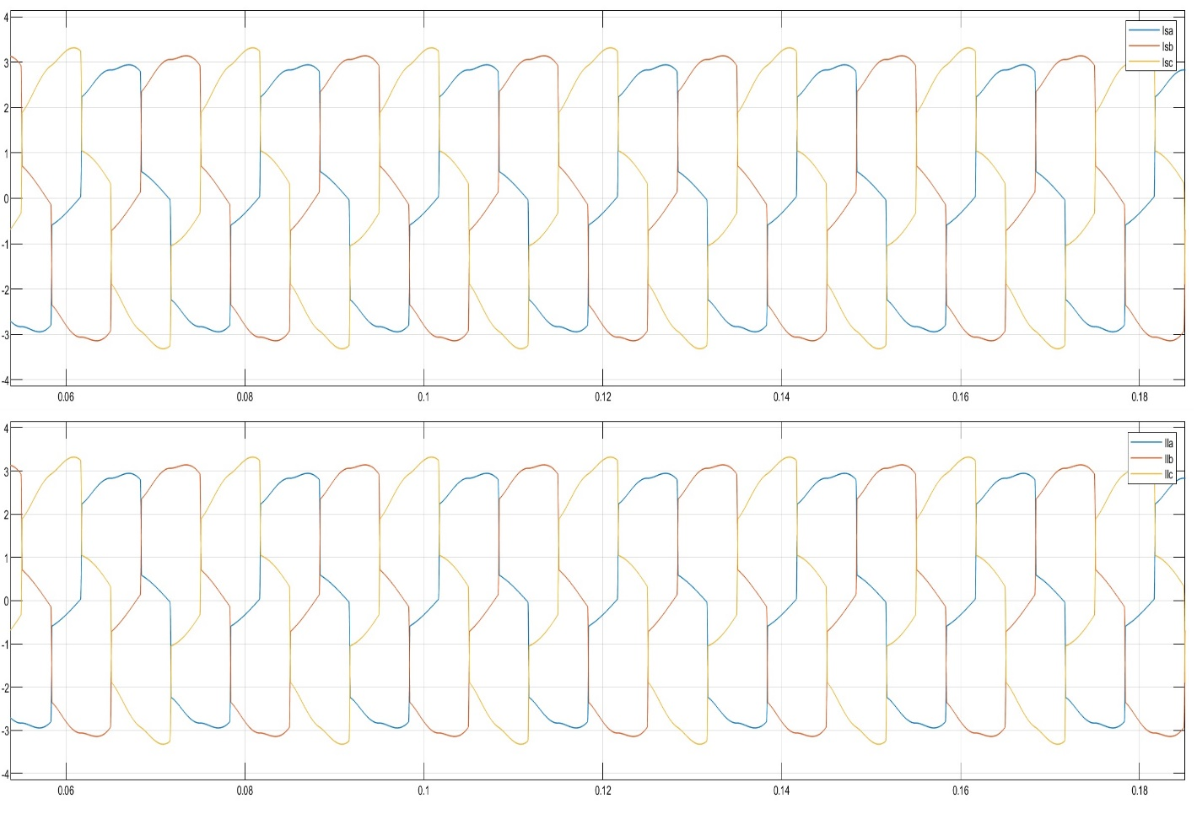

Figure 26 Waveforms of Source and Load Currents in Case 1 when DSTATCOM is not connected

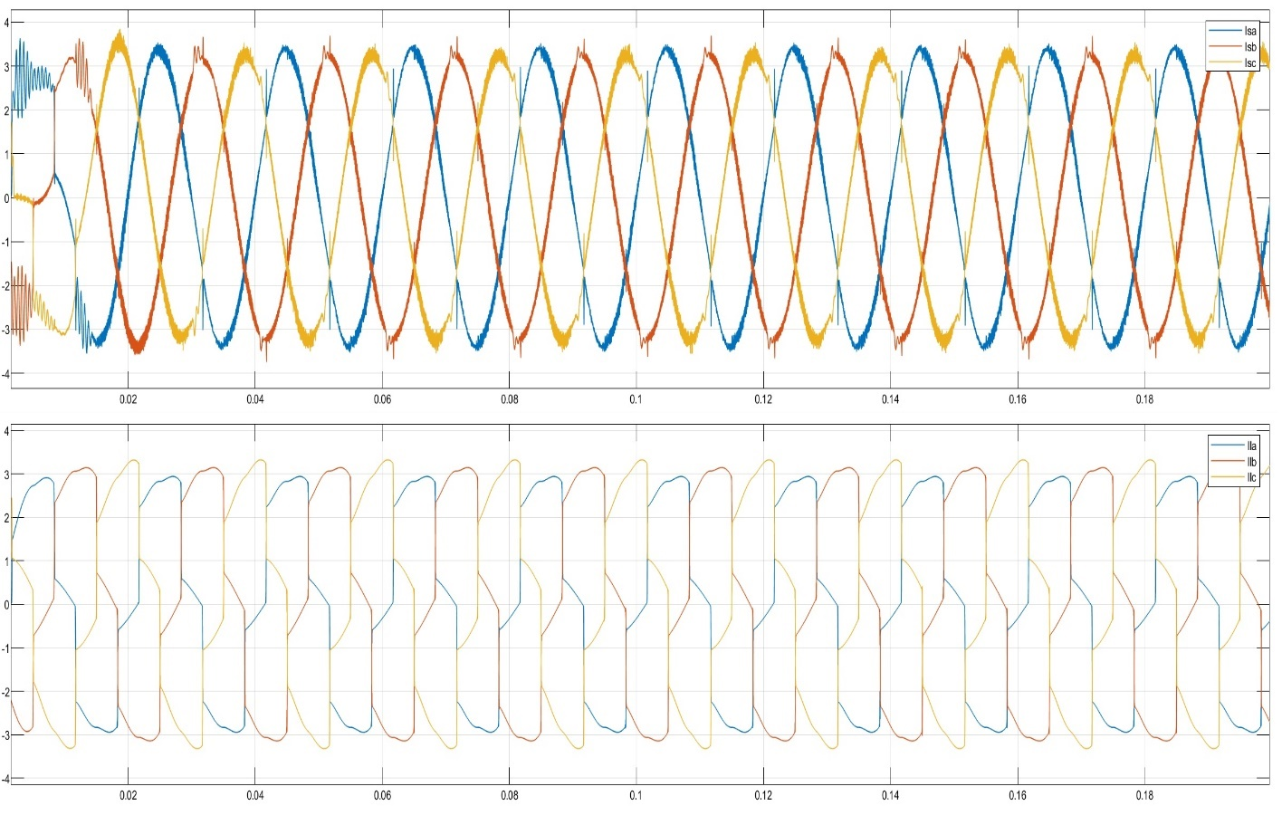

Figure 27 Waveforms of Source and Load Currents in Case 1 when DSTATCOM is connected

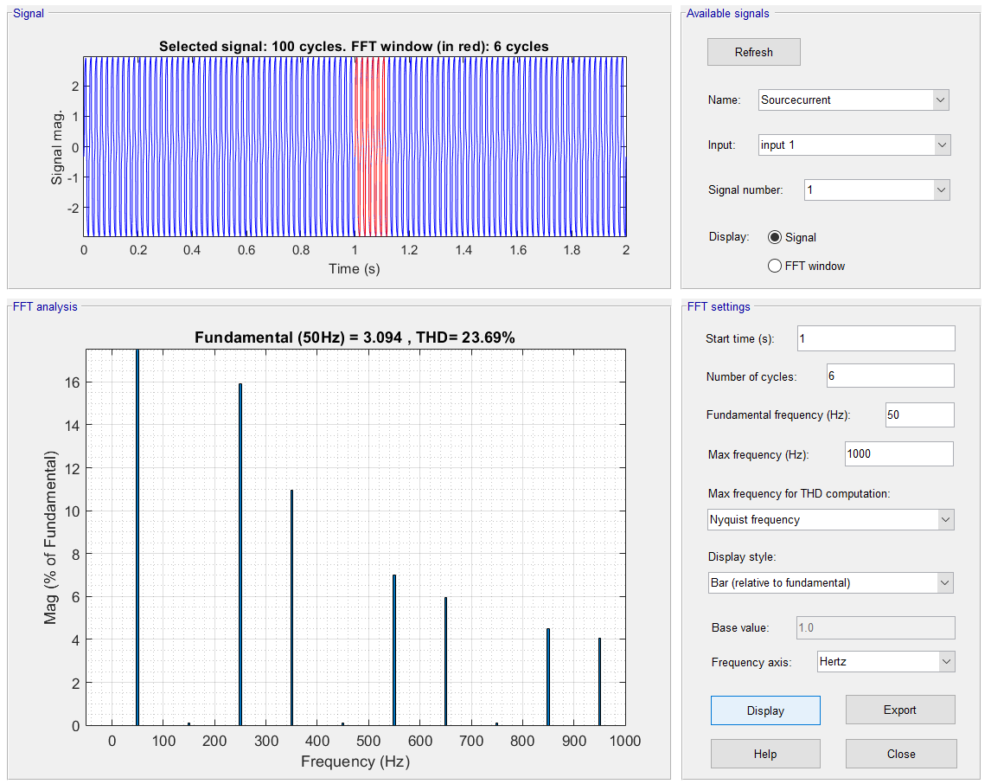

Figure 28 Screenshot of FFT Analysis of Case 1 when DSTATCOM is not connected

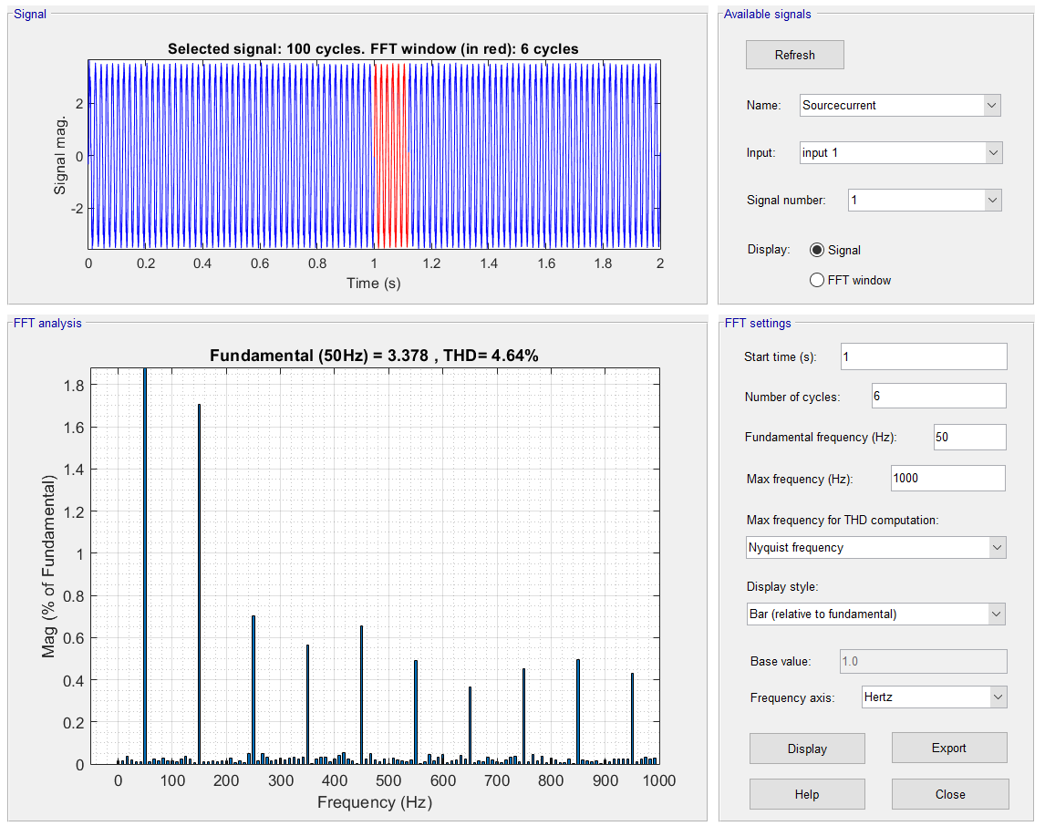

Figure 29 Screenshot of FFT Analysis of Case 1 when DSTATCOM is connected

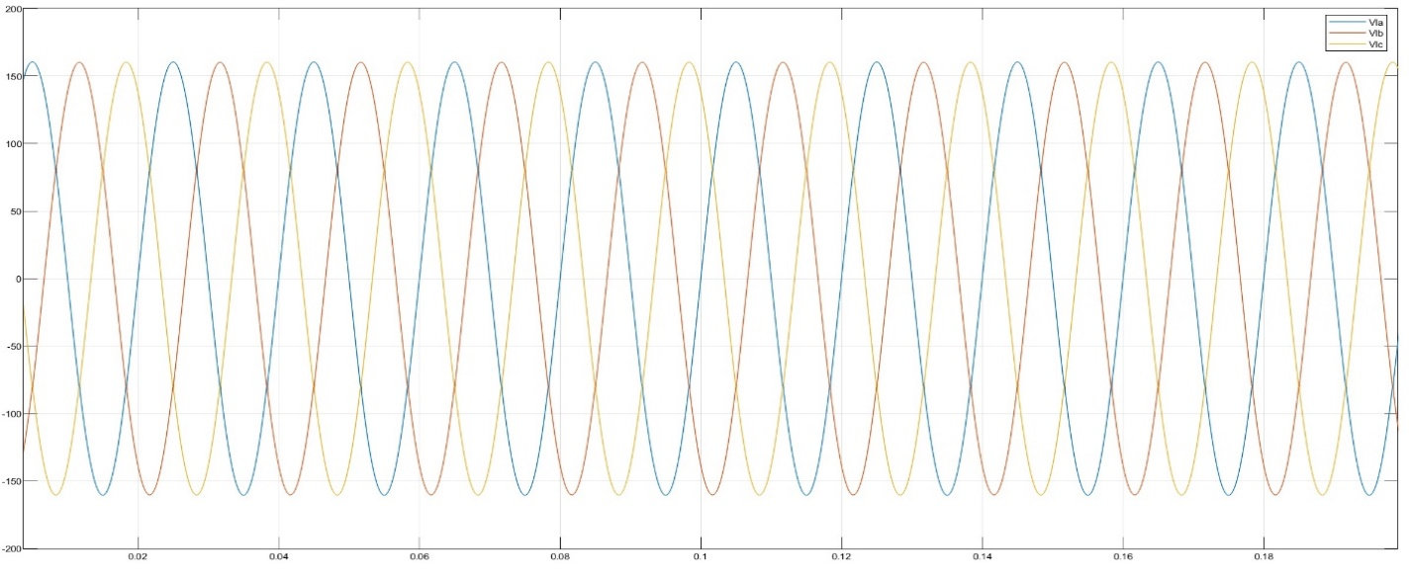

Figure 30 Load Voltages for Case 1 when DSTATCOM is not Connected

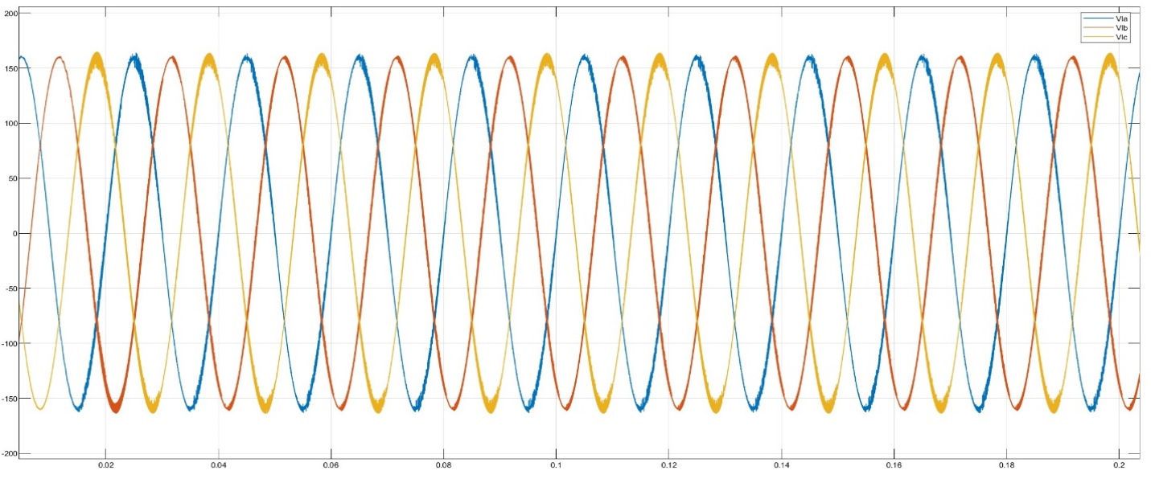

Figure 31 Load Voltages for Case 1 when DSTATCOM is connected

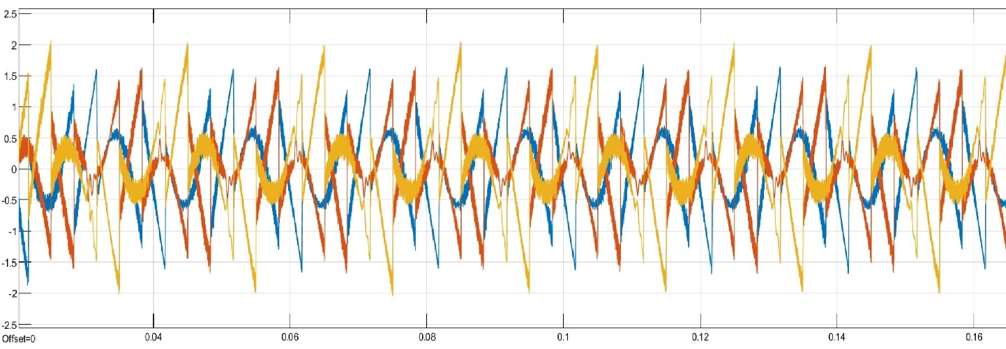

Figure 32 DSTATCOM Currents

### 4.3.2 Case 2

In case 2 additional capacitive and reactive load were added along with circuit breakers as shown in the Figure 33.

The values of capacitive and inductive loads, along with their switching time are as follows

|  |  |  |  |
| --- | --- | --- | --- |
| S.no | Load Type | Load Parameters | Switching Time |
| 1 | Inductive Load | 1000 Watts,  Positive 1000 VRA | 0.1 sec |
| 2 | Capacitive Load | 1000 Watts,  Negative 2000 VRA | 0.2 sec |

Initially the simulation was conducted without DSTATCOM and, it was observed that the total that the Total Harmonic Distortion of Source Current was:

1. 8.79% at 0.15 sec.
2. 5.66% at 0.25 sec.

The FFT Analysis is shown in Figures 34 and Figure 36.

When the DSTATCOM is connected the , it was observed that the Total Harmonic Distortion of Source Current was:

1. 1.88% at 0.15 sec.
2. 0.98% at 0.25 sec.

The FFT analysis is Shown in Figure 35 anf Figure 37.

Figure 38 and 39 shows various currents and power at Source, Load and DSTATCOM.

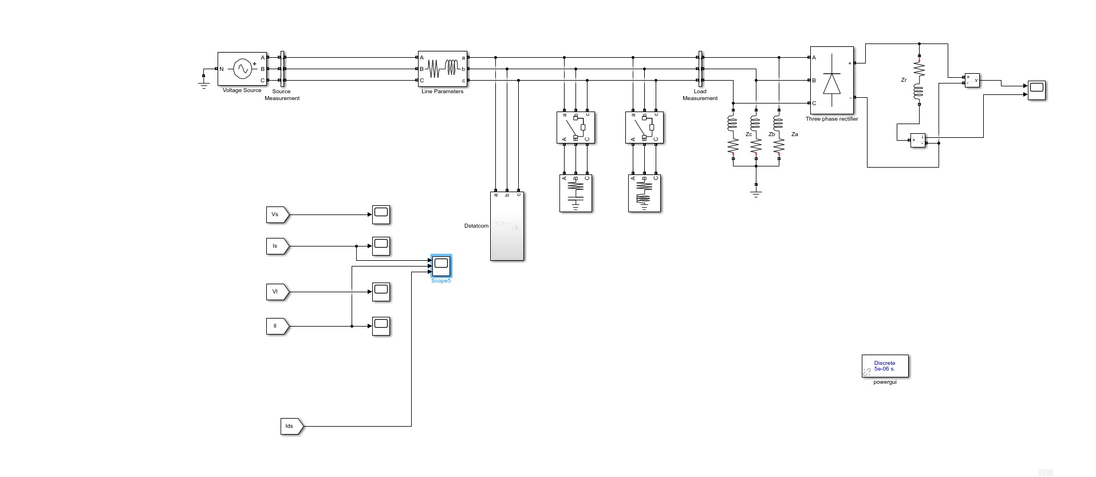

Figure 33 Model for Case 2

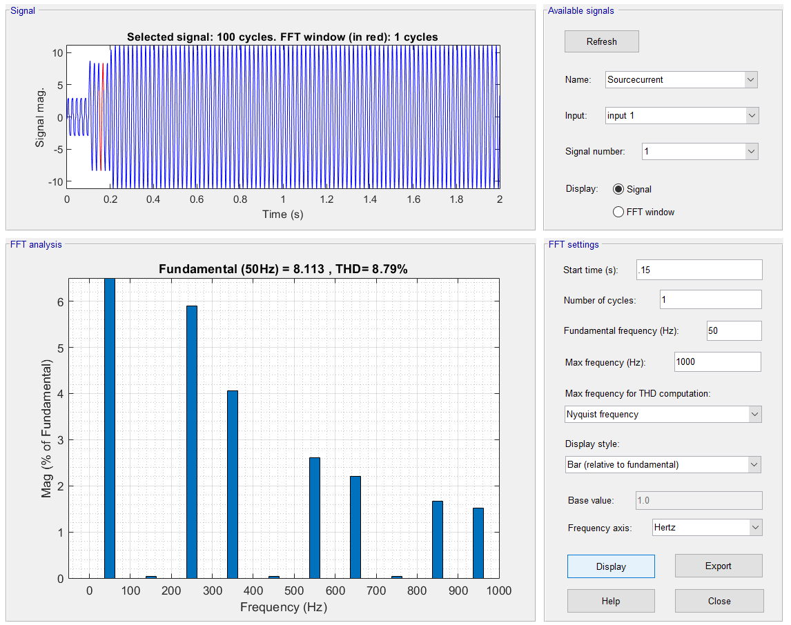

Figure 34 FFT Analysis when Inductive load is switched ON when DSTATCOM is disconnected

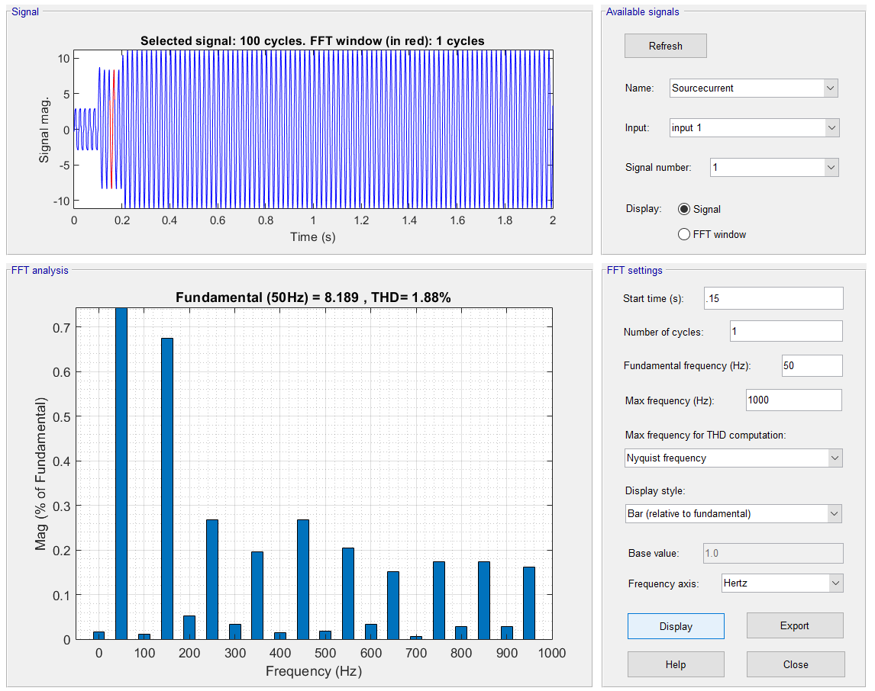

Figure 35 Analysis when Inductive load is switched ON when DSTATCOM is connected

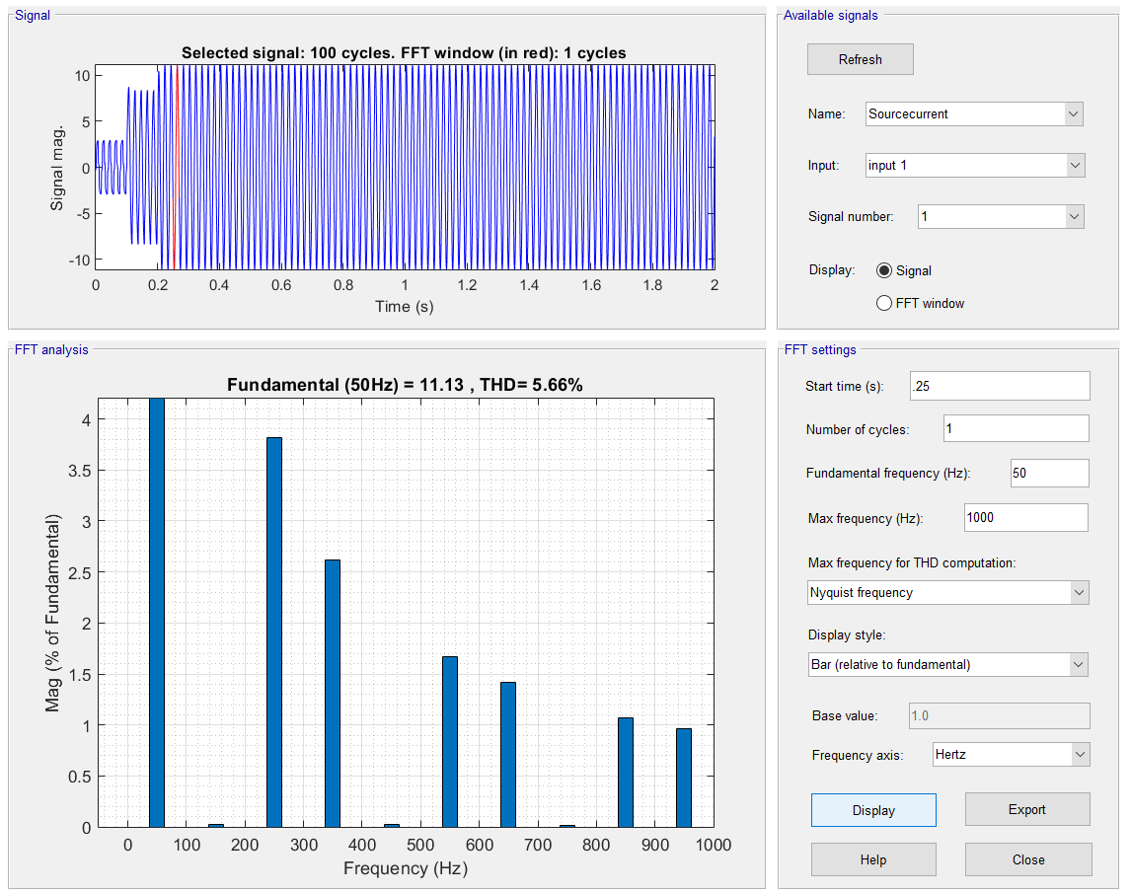

Figure 36 Analysis when Capacitive load is switched ON when DSTATCOM is disconnected

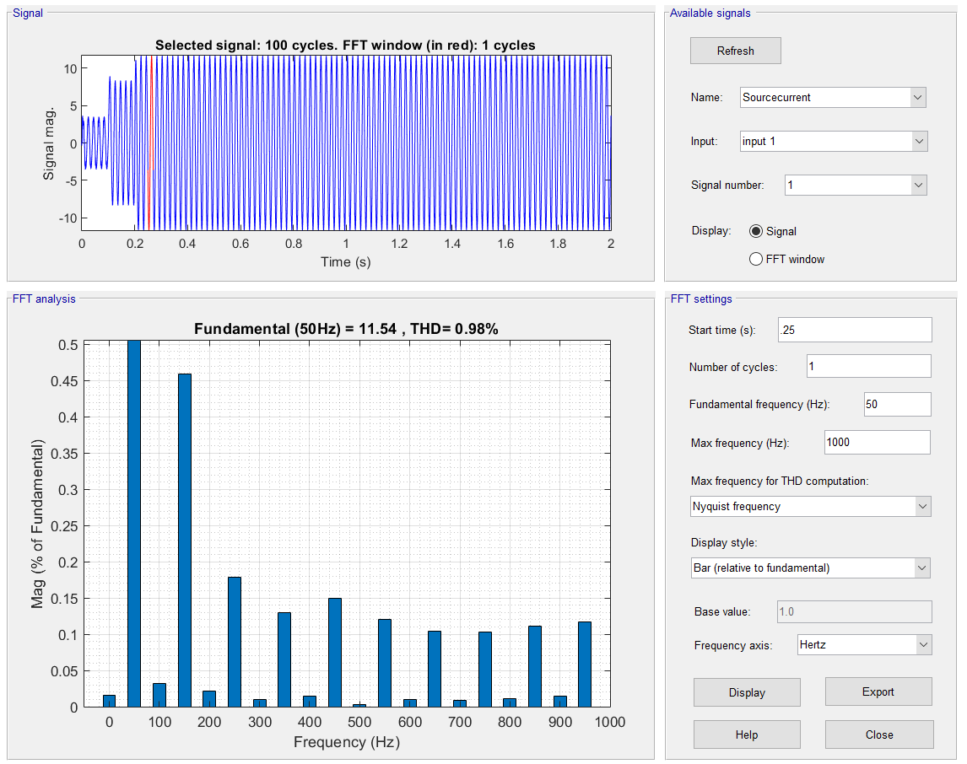

Figure 37 Analysis when Capacitive load is switched ON when DSTATCOM is connected

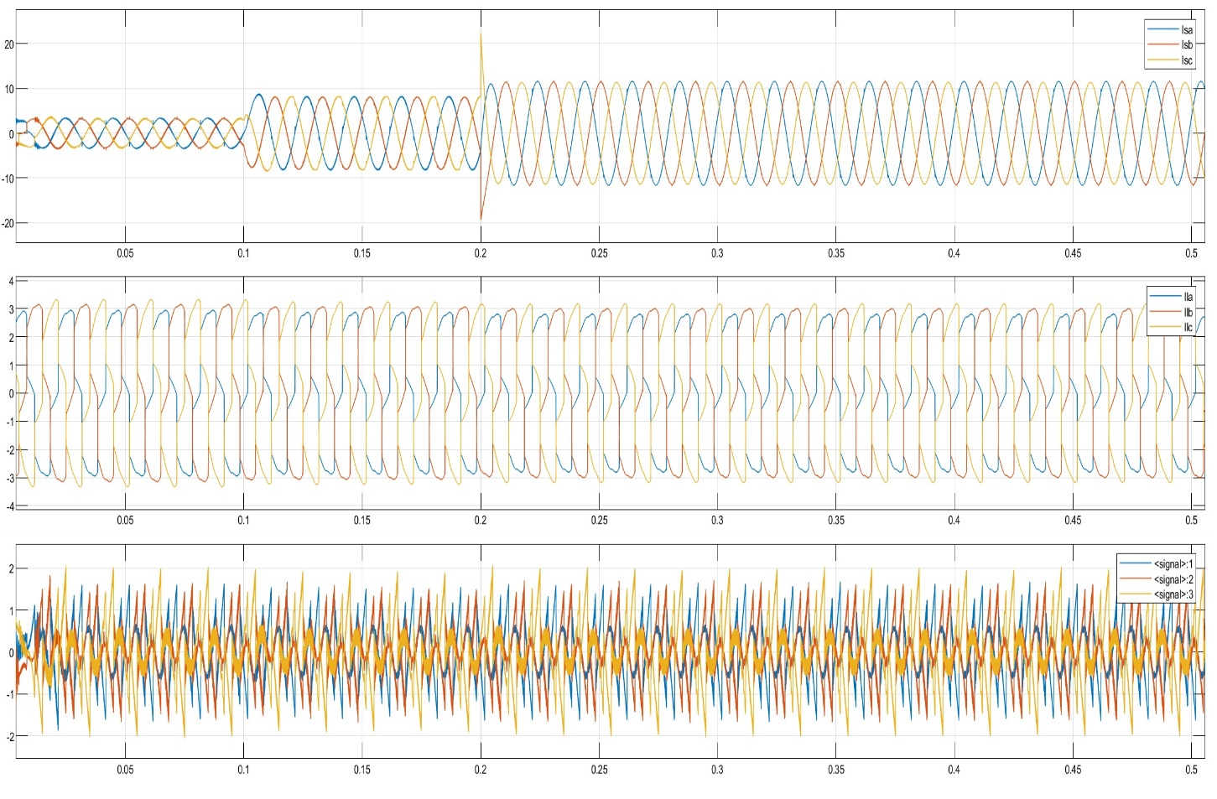

Figure 38 Source, Load and DSTATCOM currents

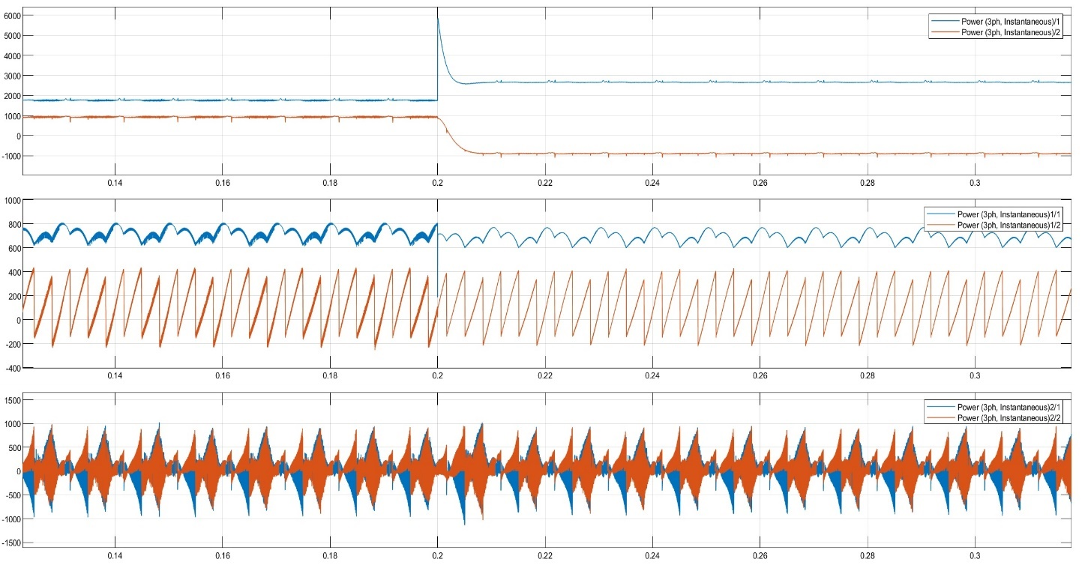

Figure 39 Active and reactive powers at Source, Load and DSTATCOM. Here Blue represents active and orange represents reactive power respectively.

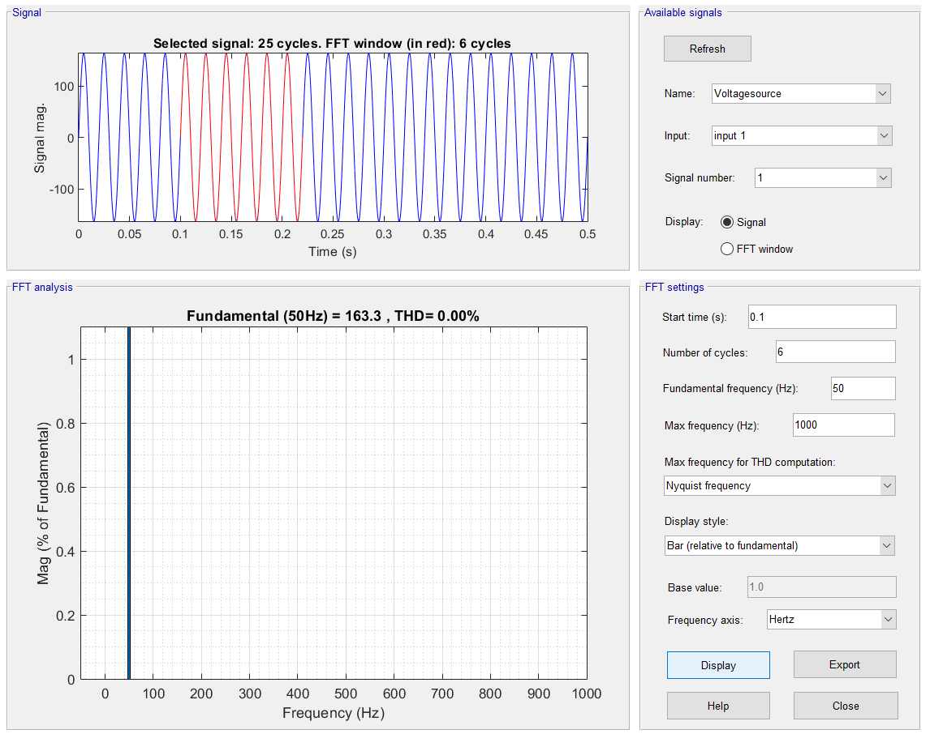

Figure 40 FFT Analysis of source voltage for case 1 with DSTATCOM connected

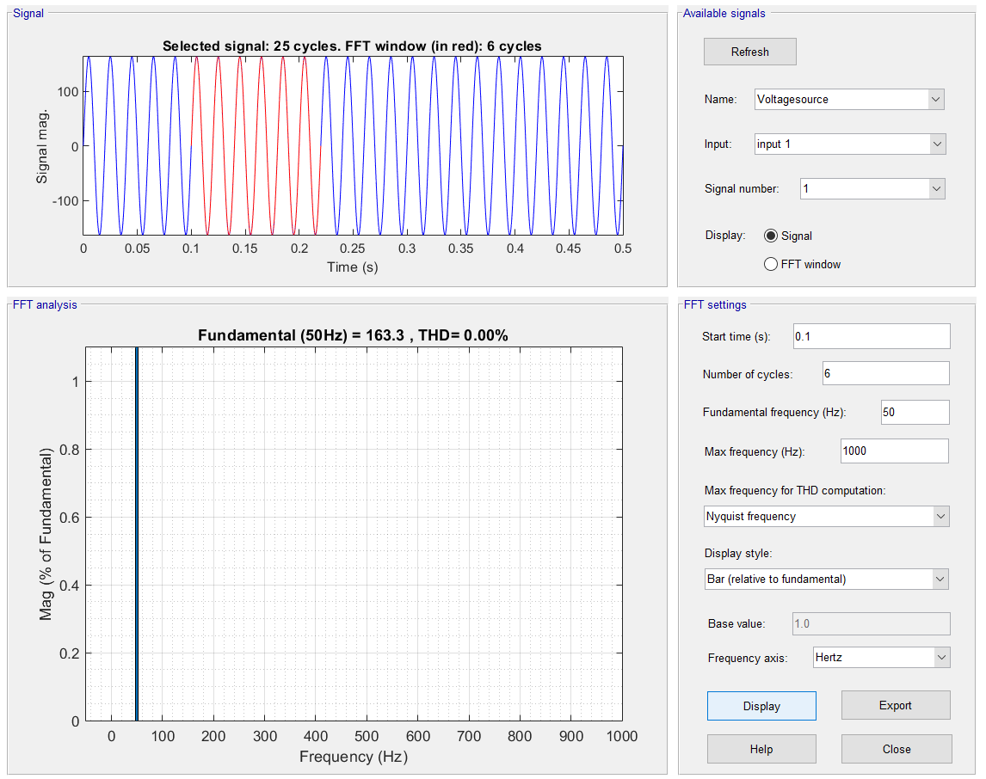

Figure 41 FFT Analysis of source voltage for case 2 with DSTATCOM connected

## 4.4 Result

From the observation following can be inferred from FFT Analysis of Source currents:

|  |  |  |
| --- | --- | --- |
| Mode of Operation | Case 1 | Case 2 |
| Without DSTATCOM | THD: 23.69% | |  |  | | --- | --- | | At 0.15 sec. | THD:8.79% | | At 0.25 sec. | THD:5.66% | |
| With DSTATCOM | THD 4.64% | |  |  | | --- | --- | | At 0.15 sec. | THD:1.88% | | At 0.25 sec. | THD:0.98% | |

From the table above we can see that, there had been a significant decrease in the Total Harmonic Distortion in source currents.

This clearly indicates that the current harmonics at the source end were successfully mitigated.

As the source currents harmonics are below 5% and from Figure 40 and Figure 41, it can be stated that design complies with the IEEE-519 stranded for voltage and current distortion at the source side.

# 5 References

[1] Sobit Gairola , Mrs. Mamta Chamoli, 2018, SRF and IRPT Methods of Dstatcom for Combined Harmonics Elimination and Reactive Power Compensation, INTERNATIONAL JOURNAL OF ENGINEERING RESEARCH & TECHNOLOGY (IJERT) Volume 07, Issue 07 (July 2018),

[2] L. A. Moran, J. W. Dixon and R. R. Wallace, "A three-phase active power filter operating with fixed switching frequency for reactive power and current harmonic compensation," in *IEEE Transactions on Industrial Electronics*, vol. 42, no. 4, pp. 402-408, Aug. 1995.

[3] W. M. Grady, M. J. Samotyj and A. H. Noyola, "Survey of active power line conditioning methodologies," in *IEEE Transactions on Power Delivery*, vol. 5, no. 3, pp. 1536-1542, July 1990.

[4] B. Singh, A. Chandra, K.Al-Haddad, "POWER QUALITY PROBLEMS AND MITIGATION TECHNIQUES", John Wiley and Sons

[5] H. Akagi, Y. Kanazawa and A. Nabae, "Instantaneous Reactive Power Compensators Comprising Switching Devices without Energy Storage Components," in IEEE Transactions on Industry Applications, vol. IA-20, no. 3, pp. 625-630, May 1984.

[6] Nagesh Geddada, Srinivas Bhaskar Karanki and Mahesh K. Mishra, “Synchronous reference frame based current controller with SPWM switching strategy for DSTATCOM”, Conference paper, December 2012, DOI: 10.1109/PEDES.2012.6484393.

[7] Anand Ahirwar and Alka Singh, “Performance of DSTATCOM control with instantaneous reactive power theory under ideal and polluted grid”, 2016 IEEE.

[8] Documentation, S. (n.d.). *Simulation and Model-Based Design*. MathWorks.

[9] Vinay M. Awasthi and V. A. Huchche, ‘Reactive power compensation using DSTATCOM”, 2016 IEEE.

[10] Sabha Raj Arya, Ambrish Chandra and Kamal Al-Haddad, “Power factor correction and zero voltage regulation in Distributio system using DSTATCOM”, *2012 IEEE International Conference on* *Power Electronics, Drives and Energy Systems December16-19,* *2012, Bengaluru, India.*

# 6 Conclusion

DSTATCOM is considered to be the one of the best ways to composite current harmonics. It can also be modified to composite voltage related power quality problem. This project was an attempt to design and study the working of a basic current harmonic compositing DSTATCOM using IRPT algorithm.

In this project there is no feedback DC bus voltage, and if the feed back was implemented it could have done a better job in compensating current harmonics.

Moreover, due to the development of new algorithms based on both time and frequency domain such as wavelet transform based algorithm have been proved to do a better power quality problem mitigation, than the one done here.